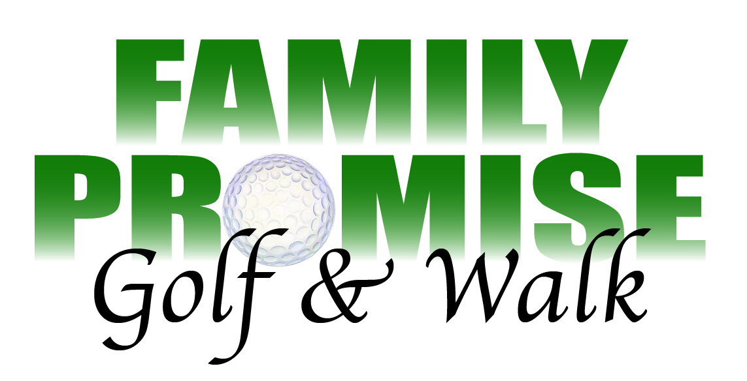

Family Promise of North Idaho Golf/Walk Fundraising Event is Friday May 12 at the Links Golf Course 10623 N. Chase Post Falls Idaho 83854. The fee for golfers is $100.00 and $35.00 for the walkers. The $100.00 fee pays for greens fees, golf cart, driving range, dinner, and the opportunity to help homeless children and their families. Sign in for the golfers begins at 12:00 with time to peruse the silent auction items before the 1:00p.m. shot-gun start. The 18 hole scramble has contests and prizes.

The Walk for Family Promise of North Idaho will be remembered as the most remarkable walk yet. Karen Olson, founder of Family Promise National, will be joining the walkers and then, speaking at dinner after the walk. The $35.00 fee will get you a walk, dinner, swag, in a drawing for $50.00 gift certificate to Marmalade a clothing store and the opportunity to help homeless children and their families. Sign-in for the group of walkers is 4:30 with time to browse the silent auction items before the 5:30 walk.

You can register for the walk or golf in two different ways. One way is to visit FPNI website at www.familypromiseni.org and download a registration sheet for either golf or walk. Fill out the sheet and mail it to FPNI P.O. Box 3682 Coeur d’Alene ID 83816 along with your check. Or register and pay online at: www.eventbrite.com/o/family-promise-of-north-idaho-13120926026

For more information contact Andy 208-660-0066
Walkers can contact Teri at riverburch1@gmail.com
Golfers can contact Kevin at kgarasky@gmail.com

