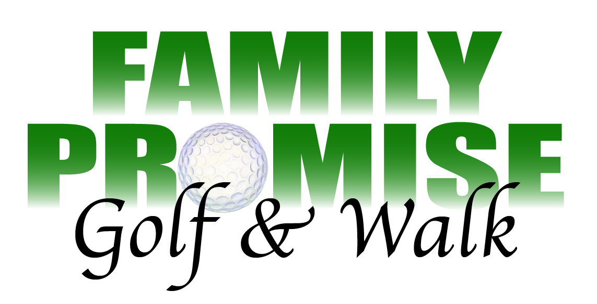
1:00 Shotgun start on Friday May 12, 2017
Links Golf Course
10623 N. Chase Rd.
Post Falls ID 82854

Golf Registration
Fees $100.00 per person
Individual we will find you a team:
Print First and Last Name______________________________________________

Contact Email _____________________________________________

Contact telephone/cell number ______________________________

Check Number: _________________________________

Team Registration:
Contact Person Name ________________________________________________

Contact Person Email _________________________________________________

Contact Person telephone/cell number __________________________________
Each team consists of 4 people. Please list your team members below:

- ____________________________________________________________
- ____________________________________________________________
- ____________________________________________________________
- ____________________________________________________________

Make your check payable to: FPNI and mail along with registration to FPNI P.O. Box 3682 Coeur d’Alene ID 83814
Email Kevin at kgarasky@gmail.com for information

